Prospect Mill Elementary School PTA
Type of Meeting: General Membership Meeting
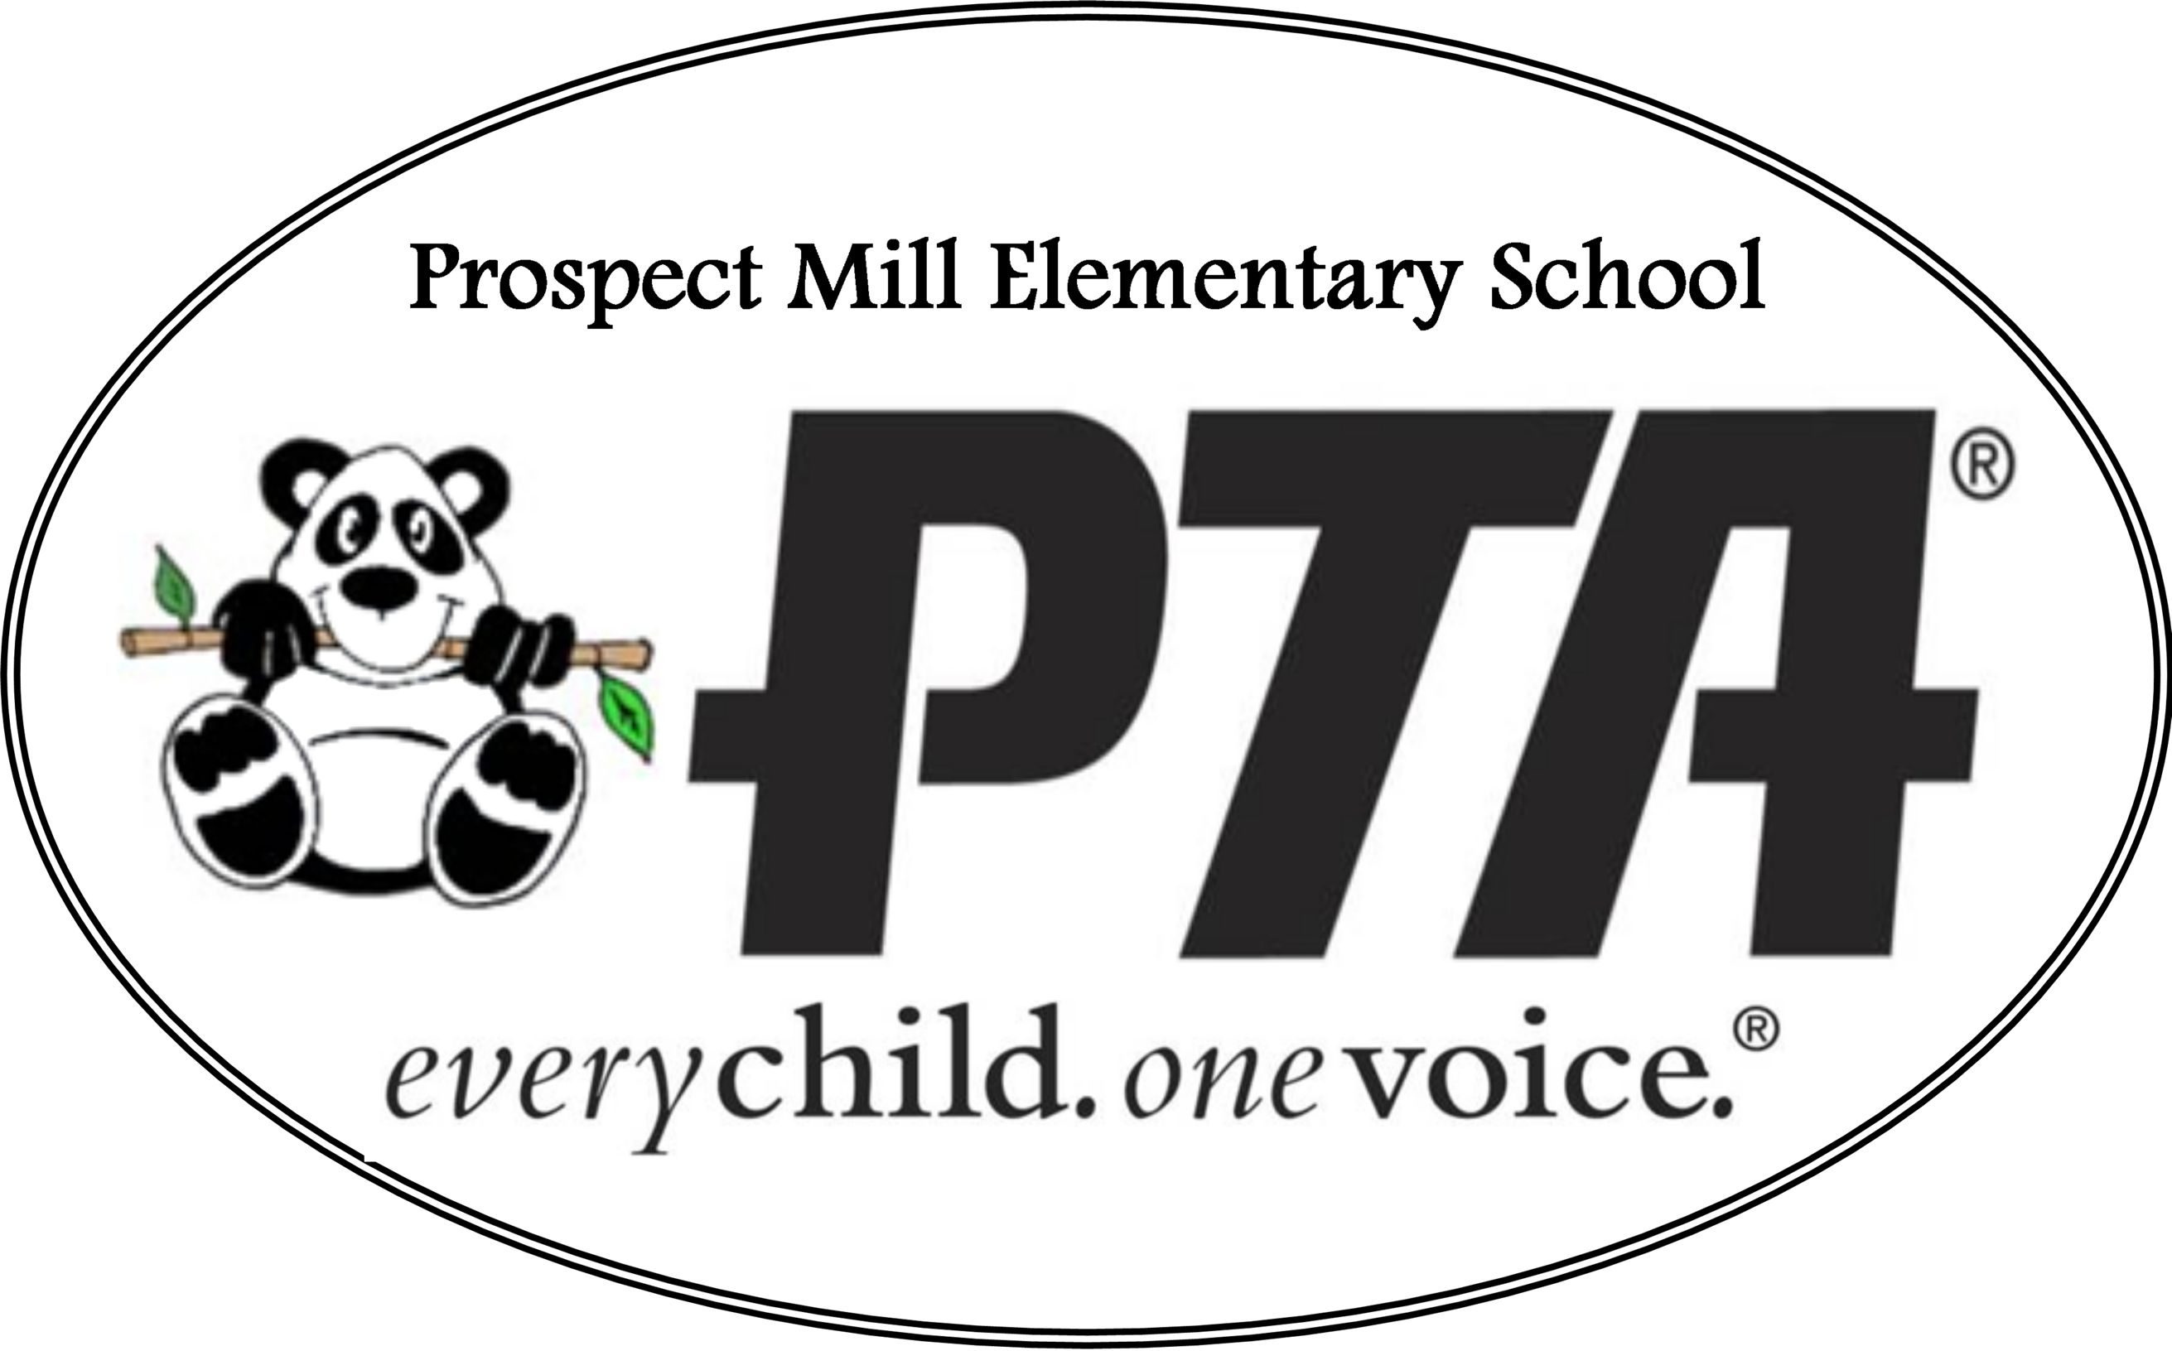

Date: October 14, 2020
Location: Prospect Mill Elementary School Parking
Lot due to Covid 19

Attendees:
Sarah Penney, Mandi White, Emily Hale, Meredith
Colburn, Lisa Rice, Heather Jacobs, Cindy Powell,
Karen Jankowiak, Lorien Covelly

Meeting start: 5:30 pm
Meeting start and welcome– Sarah Penney
Paid members raise hand – we have quorum.

Request to approve minutes from last meeting (June 3, 2020).
Lisa Rice motions; Meredith Colburn seconds the motion
Minutes approved and will be filed.

AGENDA:
VP/Membership Report, Treasurer’s report, President’s Report, Secretary’s Report, Principal’s Report, Teacher’s Report, Committee Reports, New Business

VP/Membership Report:
VP, Laura Lenker, and Membership Chair, Miguel Zambrano, could not make this meeting. Sarah Penney reports that we have met our membership goal of 200 as of this evening.

Treasurer’s Report:
Treasurer, Mandi White, reports that our budget looks very different than usual due to the circumstances of Covid-19 restrictions. Income wise, we will be focusing on community nights, membership, corporate donations, spirit wear, and Square 1 Art. For community nights we are looking at expanding how many we have by doing several dining spirit nights at places where people can easily order and take out. Membership goal has been made. We are shooting for a larger corporate donation because we had one extremely donation thanks to the Spigler family ($1,750). Square 1 Art may work a little differently in the spring but with the help of the art teacher we will be able to make it work. The balance forward looks big but is paying for the playground in this fiscal year.

Expenses include: PTA Organization Events (beautification -bird feeder in honor of the Spigler family’s service to PMES, charitable support, staff appreciation, 5th grade end of year celebration), Student Recognition (Patriot Program – 5th grade award, Character Education/ Recognition– spirit sticks, acts of kindness, Reflections), Supports Our School (Nurse station supplies, future playground repairs, playground decals), and normal operating PTA expenditures.

Request for questions or corrections. No questions or corrections.
Motion to approve the 2020-2021 budget.
Meredith Colburn motions to approve; Lisa Rice seconds the motion to approve the 2021 budget.
ALL IN FAVOR of budget as presented.
Motion passes unanimously.
The budget is approved and will be filed.

President’s Report:
Thank you to the staff and teachers for all of their support. There has been a great outpouring of appreciation from the families. We greatly appreciate your support and how well online learning is going. The Parade went well and everyone was excited to see Pax but especially excited to see Mrs. Jankowiak. With the return of all of our wonderful staff at PMES returning to the building this week, the PTA provided treats for everyone. A huge thank you to Newberry Café & Bakery, Starbucks – Bel Air Plaza, and Safeway for their generous donations. Our Calendar for the year is empty as we cannot really confirm anything because we don’t know what will be happening. We will add events as we are allowed per Covid-19 restrictions. We are planning a scavenger hunt and more prizes for students.

Recording Secretary’s Report:
Emily Hale was elected as recording secretary on September 24, 2020. Thank you to Cailin Kehoe for her service as our previous secretary and volunteering.

Corresponding Secretary’s Report:
Action to write thank you notes to all of the places that donated to the teacher’s first day back.

Principal’s Report:
We are very thankful for the PTA support in the first day back and overall support. We are in the 3rd phase of opening. Starting on the 19th we will have kids 1 day a week. We had to work on cohorts individually and send emails to each group. Come November 4th 3rd – 5th grade will be invited to attend. There are a lot of logistics to sort out with buses and seats. People only ride 1 bus to and from. Learning Support Centers no longer exist. We are using the gymnasium and cafeteria for eating and using individual desks. Masks are only allowed to be removed at lunch and recess. We have asked parents to bring in an extra mask in case one gets dirty or wet. All kids are using hand sanitizer when they walk in. Everyone is doing great! I am so impressed with the students and teachers. On November 19th K-2nd will be coming in 2 days a week. At that time, if you opted out for 1 day a week, you will have the option to opt in for 2 days a week. December 7th everyone will be coming 2 days. We are doing in person testing because of the Senate bills stating that it must be done. We already did 1st, 2nd, 4th, and 5th. This week we will be doing 3rd grade. We do not know what the state testing will look like. Chrome books have not arrived for PMES yet. The school is following the recovery timeline. We are here to support families and students. Please let us know if there is anything we can do to help. With that said, I would like to introduce Mrs. Heather Jacobs who will be the Parent and Community Engagement (PACE) Liaison for Prospect Mill Elementary.

Teacher/Staff Report:
Mrs. Jacobs: PACE is about supporting our families and creating events. We work closely with PTA standards. I hope to work with our PTA to have meaningful events for our families. As a collective, the PACE group consists of about 50 liaisons. We have had one meeting and it was great to bounce ideas off one another. We have some virtual ideas for engagement. We are here to support wherever is needed to reach everyone.

Mrs. Covelly: We are keeping the PMES website up-to-date with all information so please keep checking it.

Mrs. Powell: We are all so grateful and thankful for Mrs. Jankowiak,
Mrs. Covelly, and the support we’ve seen from everyone to include the PTA and parents.

Committee Reports:
Nothing to report.

New Business:
Nothing to report.

Meeting wrap: 6:26 pm

Minutes respectfully recorded by Emily Hale, Recording Secretary

